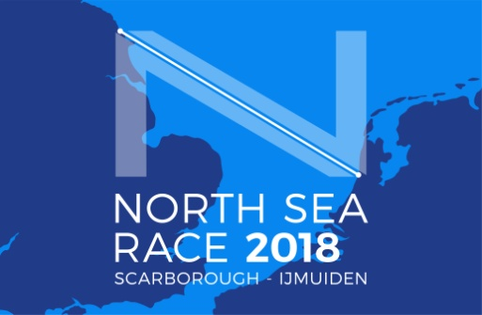

RACE DECLARATION

Scarborough Yacht Club North Sea Race 2026

To: The North Sea Race Secretary, Scarborough Yacht Club:

YACHT NAME: ……………………………………………………..SAIL NUMBER: …………………..

I declare that the above yacht completed the Scarborough Yacht Club North Sea Race 2026 sponsored by
W BOYES & CO LTD in accordance with the Sailing Instructions and the following to be the Finish Time:

Finish Date ……………………………Finish Time BST hh:mm:ss: …………………………….

Yacht Ahead: ………………………………………………. Sail Number: ………………………….

Yacht Behind: ………………………………………………. Sail Number: ………………………….

SIGNED: ……………………………………………………….. (Owner/Owner’s representative)

Emergency use of alternative propulsion [ISAF Rule 42.3(i)]

Time of use:……………………………………. Duration:………………………………………………

GPS Position one:……………………………. GPS Position two:……………………………………

Propulsion used:……………………………………………………………………………………………….

Situation arising:……………………………………………………………………………………………….

SIGNED: ……………………………………………………….. (Owner/Owner’s representative)

